LAB 6 TASK

TASK 01:

A company wants to offer a discount to customers who purchase products in bulk. The company has a fixed price for each product, and they want to calculate the total cost for a customer based on the quantity purchased. Additionally, for every 5th product, the customer gets a discount of 10%.

Write a C program that:

1. Takes as input the price of a single product.

2. Takes as input the total quantity of products the customer wants to buy.

3. Calculates the total cost, applying a 10% discount on every 5th product.

**Source code:**

**#include<stdio.h>**

**int main()**

**{**

**int price,total_cost,quantity,i;**

**printf("Enter the price of each product:");**

**scanf("%d",&price);**

**printf("ENTER THE QUANTITY OF PRODUCT:");**

**scanf("%d",&quantity);**

**for(i=1;i<=quantity;i++)**

**{**

**if(i%5==0)**

**{**

**total_cost += price*0.9;**

**}**

**else**

**total_cost+= price;**

**}**

**printf("TOTAL COST AFTER DISCOUNT IS %d",total_cost);**

**}**

**OUTPUT**

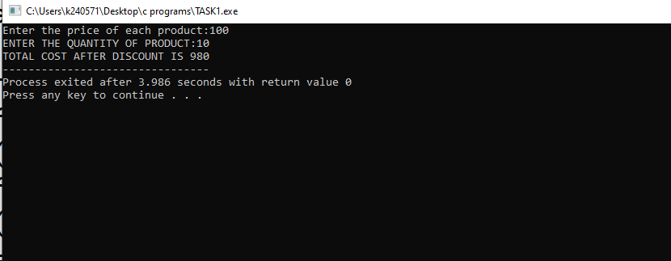

TASK 02:

You are developing a feature for a banking application. The bank wants to identify certain account numbers that have a special pattern: the account number must be a palindrome. A

palindrome is a number that reads the same forwards and backwards. The bank wants you to write a program that checks if an account number is a palindrome.

Requirements:

1. The program should prompt the user to input an account number (a positive integer).

2. Your program should determine whether the number is a palindrome.

3. Display an appropriate message indicating whether the account number is a palindrome.

Additionally:

Allow the program to repeatedly ask the user for another account number until they enter a negative number, at which point the program should stop.

**SOURCE CODE:**

**#include<stdio.h>**

**int main()**

**{**

**long int account_no,orginal_no,reverse_no,reminder;**

**while(1)**

**{**

**reverse_no=0;**

**printf("ENTER YOUR ACCOUNT NUMBER(NEGATIVE NUMBER TO QUIT):");**

**scanf("%ld",&account_no);**

**if(account_no<0)**

**{**

**printf("INVALID ACCOUNT NO");**

**return 0;**

**}**

**orginal_no = account_no;**

**while(account_no!=0)**

**{**

**reminder = account_no%10;**

**reverse_no = reverse_no *10+reminder;**

**account_no/=10;**

**}**

**if(orginal_no==reverse_no)**

**{**

**printf("ACCOUNT NUMBER IS PALIDROME\n");**

**}**

**else**

**printf("NOT A PALIDROME\n");**

**}}**

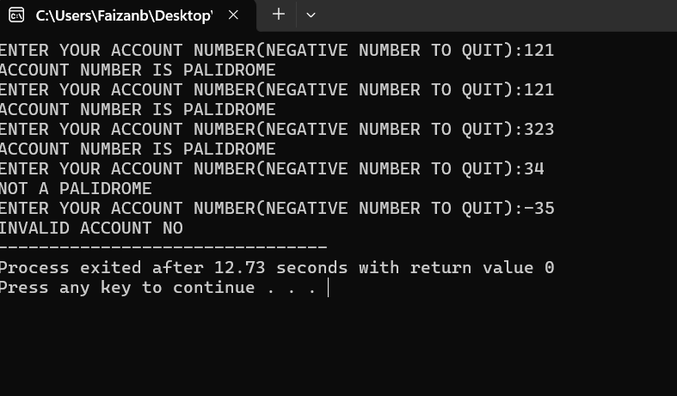TASK 03:

Write a program to calculate the factorial of a number input from user.

**SOURCE CODE**

**#include<stdio.h>**

**int main()**

**{**

**int n,fact=1,i;**

**printf("ENTER A NUMBER:");**

**scanf("%d",&n);**

**for(i=1;i<=n;i++)**

**{**

**fact= fact *i;**

**}**

**printf("FACTORIAL OF NUMBER IS %d",fact);**

**}**

**OUTPUT**

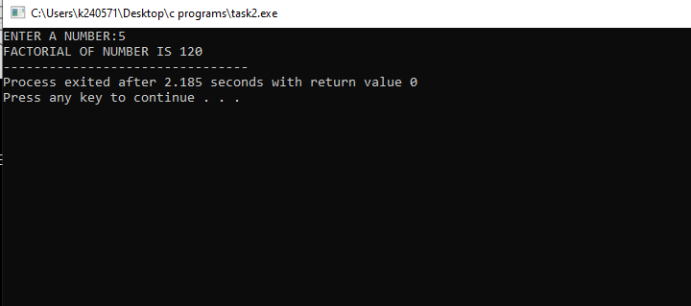

TASK 4:

You are developing a simple program for a small store that sells fruit. The store owner wants to keep track of the daily sales. Every day, the store sells a certain number of apples, oranges, and bananas. You need to write a program that calculates the total amount of fruit sold over 7 days.The store owner provides the following details:

1. The program should prompt the user to input the number of apples, oranges, and bananas sold each day.

2. Use a loop to repeat this process for 7 days.

3. After gathering the data, calculate and display:

o The total number of apples, oranges, and bananas sold over the week.

o The total number of all fruits sold combined over the week.

for example:

Day 1:

Enter the number of apples sold: 10

Enter the number of oranges sold: 5

Enter the number of bananas sold: 8

Day 2:

Enter the number of apples sold: 7

Enter the number of oranges sold: 6

Enter the number of bananas sold: 4

o Total apples sold in the week: 50

o Total oranges sold in the week: 40

o Total bananas sold in the week: 45

o Total fruits sold in the week: 135

**SOURCE CODE**

**#include<stdio.h>**

**int main()**

**{**

**int no_apples,no_oranges,no_bananas,total_app,total_org,total_ban, total_fruits_sold;**

**for(int i=0;i<7;i++)**

**{**

**printf("ENTER THE NO OF APPLES ,ORANGES AND BANANAS SOLD IN DAY %d:\n",i+1);**

**scanf("%d%d%d",&no_apples,&no_oranges,&no_bananas);**

**total_app+=no_apples;**

**total_org+=no_oranges;**

**total_ban+=no_bananas;**

**total_fruits_sold=total_app+total_org+total_ban;**

**}**

**printf("TOTAL APPLES SOLD IN WEEK ARE %d\n",total_app);**

**printf("TOTAL ORANGES SOLD IN WEEK ARE %d\n",total_org);**

**printf("TOTAL BANANAS SOLD IN WEEK ARE %d\n",total_ban);**

**printf("TOTAL FRUITS SOLD IN WEEK ARE %d",total_fruits_sold);**

**}**

**OUTPUT**

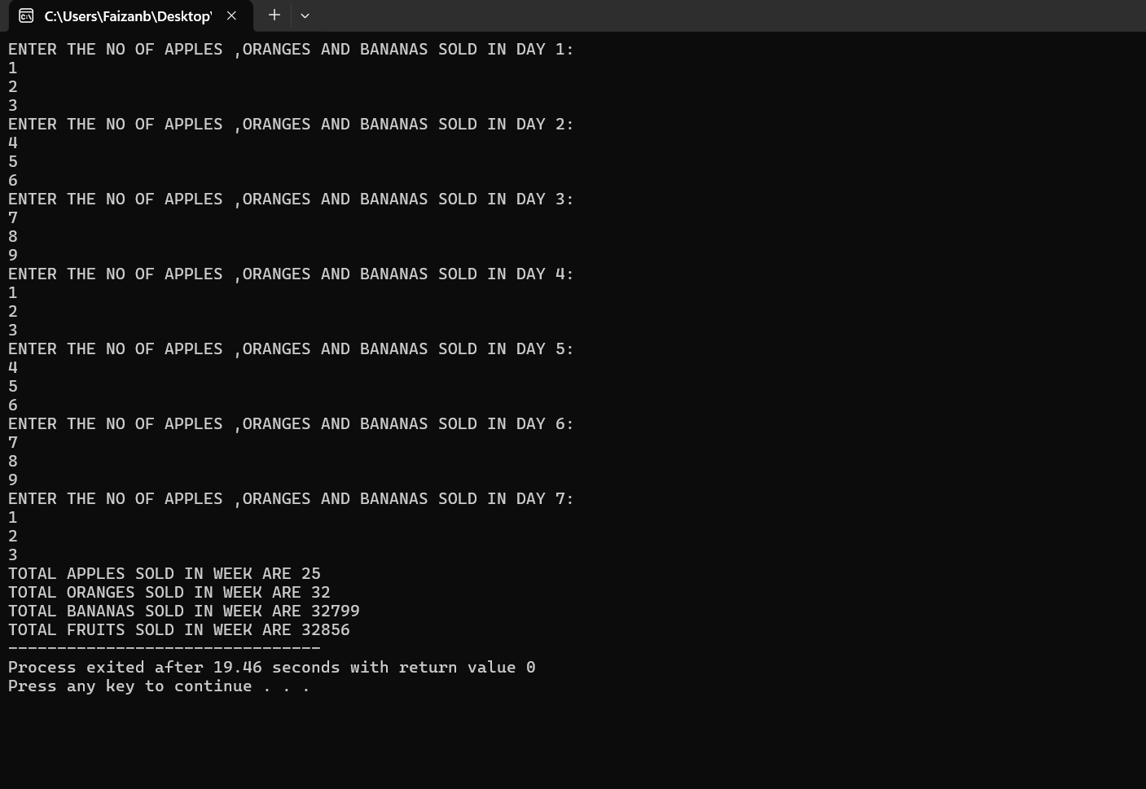

TASK 05:

You have been hired by a tech company to develop a small utility program for their internal

tools. One of the tasks involves processing large sets of data where each entry is an integer, and

they need to quickly analyze the structure of these numbers. Specifically, the company needs to

know how many digits each integer contains.

Write a program that will take a single integer as input and output the number of digits in that

integer. This utility will help the company efficiently organize their data by understanding the

size of the numbers.

Requirements:

1. The program should prompt the user to input any integer (positive or negative).

2. The program should then calculate and display how many digits are in the given integer,

ignoring the negative sign if present.

For example:

Input:

• Integer: -12345

Output:

• Number of digits: 5

**Source code**

**#include<stdio.h>**

**int main()**

**{**

**int n,count=0;**

**printf("ENTER A INTEGER:");**

**scanf("%d",&n);**

**do**

**{**

**n=n/10;**

**count++;**

**}**

**while(n!=0);**

**printf("TOTAL DIGITS IN NUMBER ARE %d",count);**

**}**

**OUTPUT**

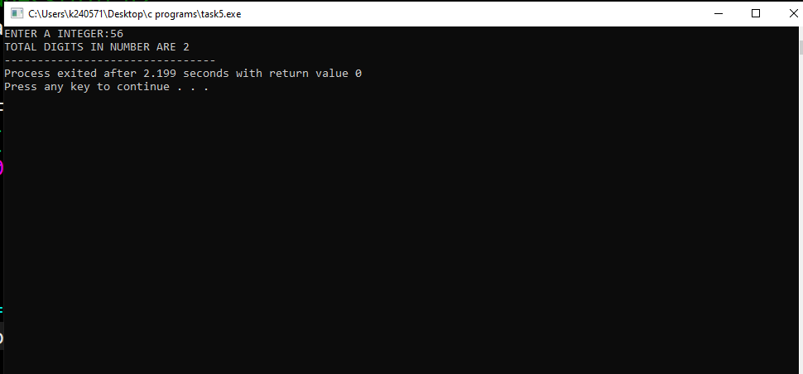

TASK 06:

Create a simple number guessing game where the program randomly selects a number between 1

and 100. The user has to guess the number, and the program will provide feedback on whether

the guess is too high, too low, or correct. The game continues until the user guesses the correct

number.

For example:

Guess the number (between 1 and 100): 50

Too low! Try again.

Guess the number (between 1 and 100): 75

Too high! Try again.

Guess the number (between 1 and 100): 63

Congratulations! You guessed the number!

**SOURCE CODE**

**#include<stdio.h>**

**#include<stdlib.h>**

**#include<time.h>**

**int main()**

**{**

**int n,guess_no;**

**srand(time(0));**

**n=(rand()%100)+1;//ADDED 1 so that the range becomes 1 to 100 instead of 0 to 99**

**while(n!=guess_no)**

**{**

**printf("ENTER YOUR GUESS NO:\n");**

**scanf("%d",&guess_no);**

**if(guess_no<n)**

**printf("Too low! Try again.\n");**

**else if(guess_no>n)**

**printf("Too high! Try again.\n");**

**}**

**printf("Congratulations! You guessed the number!");**

**}**

**OUTPUT**

